Clinic Management System
By Hafsa Taj

Milestone | Date | Version | Remarks
ERD | April 23, 2026 | 0.1
Schema | April 23, 2026 | 1.1

ERD Diagram
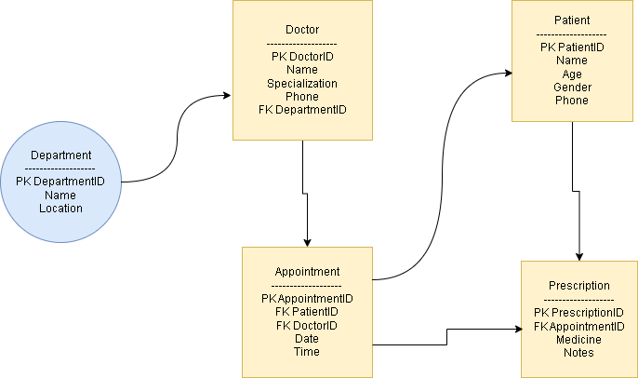

Schema
CREATE TABLE Department (
DepartmentID INT NOT NULL AUTO_INCREMENT,
Name VARCHAR(100) NOT NULL,
Location VARCHAR(150) NOT NULL,
CONSTRAINT pk_department PRIMARY KEY (DepartmentID)
);
CREATE TABLE Patient (
PatientID INT NOT NULL AUTO_INCREMENT,
Name VARCHAR(100) NOT NULL,
Age TINYINT UNSIGNED NOT NULL,
Gender ENUM('Male', 'Female', 'Other') NOT NULL,
Phone VARCHAR(20) NOT NULL,
Address VARCHAR(255) NULL,
CONSTRAINT pk_patient PRIMARY KEY (PatientID)
);
CREATE TABLE Doctor (
DoctorID INT NOT NULL AUTO_INCREMENT,
Name VARCHAR(100) NOT NULL,
Specialization VARCHAR(100) NOT NULL,
Phone VARCHAR(20) NOT NULL,
DepartmentID INT NOT NULL,
CONSTRAINT pk_doctor PRIMARY KEY (DoctorID),
CONSTRAINT fk_doctor_dept FOREIGN KEY (DepartmentID)
REFERENCES Department (DepartmentID)
ON UPDATE CASCADE
ON DELETE RESTRICT
);
CREATE TABLE Appointment (
AppointmentID INT NOT NULL AUTO_INCREMENT,
PatientID INT NOT NULL,
DoctorID INT NOT NULL,
Date DATE NOT NULL,
Time TIME NOT NULL,
CONSTRAINT pk_appointment PRIMARY KEY (AppointmentID),
CONSTRAINT fk_appt_patient FOREIGN KEY (PatientID)
REFERENCES Patient (PatientID)
ON UPDATE CASCADE
ON DELETE RESTRICT,
CONSTRAINT fk_appt_doctor FOREIGN KEY (DoctorID)
REFERENCES Doctor (DoctorID)
ON UPDATE CASCADE
ON DELETE RESTRICT
);
CREATE TABLE Prescription (
PrescriptionID INT NOT NULL AUTO_INCREMENT,
AppointmentID INT NOT NULL,
Medicine VARCHAR(200) NOT NULL,
Notes TEXT NULL,
CONSTRAINT pk_prescription PRIMARY KEY (PrescriptionID),
CONSTRAINT fk_presc_appt FOREIGN KEY (AppointmentID)
REFERENCES Appointment (AppointmentID)
ON UPDATE CASCADE
ON DELETE CASCADE
);

